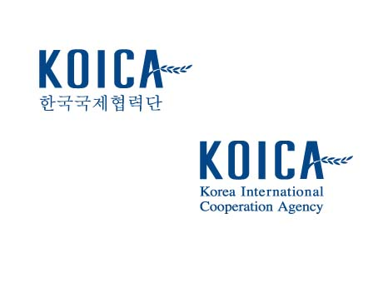 | Logo of your organization

Project Title (Duration/ Budget)
Name of Partner Country
Project/Program Concept Paper

DD, MM, YYYY,

Applicant Information
Name
Position
Organization
Telephone
E-mail
Address

PROJECT/PROGRAM CONCEPT PAPER (PCP)

SECTION 1. BASIC PROJECT INFORMATION
1.1 | Country
1.2 | Title
1.3 | Location(s)
1.4 | Duration | XX months (2023-20XX)
1.5 | Budget (total) | US$ XX million
1.6 | Objectives
1.7 | Beneficiary
1.8 | Implementing organization | Name :

SECTION 2. PROJECT RATIONALE
2.1 | SI SITUATION ANALYSIS: Please provide a brief introduction to the current social and economic situation related to the Project (geographic region and beneficiaries, etc.)  Pl please describe the problem or critical issue which the project seeks to resolve, how the problem was identified, and how will the Project address the problem. If relevant, analysis on gender equality needs to be described.
2.2 | COUNTRY DEVELOPMENT STRATEGIES AND POLICIES: Please describe how the Project relates to other relevant national development strategies and policies, and provide the ongoing status of their implementation, results and effects, if any.
2.3 | JUSTIFICATION FOR INTERVENTION: Please describe how the need for the Project was determined, and what the rationale/justification for the Project (why the Project is considered to be the most effective way the problem is resolved.).
2.4 | LESSONS LEARNED: Please describe what lessons Partner Country has drawn on (from Partner Country’s own and other’s past experience) in designing this Project.
SECTION 3. PROJECT DESCRIPTION
3.1 | Objective/Outcome/Output: Please outline the objectives, the expected outcomes, and outputs of the Project.
3.2 | Activities: Please describe what will be carried out in terms of planned activities, their timing and duration, and who will be responsible for each activity. It should indicate the sequence of all major activities and implementation milestones.
3.3 | Budget: Please provide a brief requirement by Outputs and Activities. The budget requirement is not a full and well-defined. The detailed budget requirement will be fully elaborated after the PCP is selected. Nevertheless, this information is to help KOICA to better understand the project.
 | Output | Activity | Proposed budget  (in USD)
 | Inno-hub building constructed (Apprx 2,300㎡) | Establishment of Inno-hub including design, supervision | 1,000,000
 | Government officials trained
 | Total

SECTION 4. STAKEHOLDER ANALYSIS
4.1 | TARGET BENEFICIARY: Please describe the following information: a) direct and indirect/wider beneficiary group, b) number of beneficiary, with gender segregation if necessary (e.g. 300 children rather than children in 3 schools), c) how the target group was identified, d) why they were selected as target group, e) how intended beneficiaries have been involved in Project design, and their expected role in Project implementation and evaluation. If relevant, the target group needs be disaggregated by sex.
4.2 | OTHER STAKEHOLDERS: Please describe other stakeholders (e.g. partner government agency, international organization, NGO, donor agency, etc.), if any, including a) name/group, b) respective role(s) and cooperation/coordination mechanism, etc.

SECTION 5. PROJECT MANAGEMENT AND IMPLEMENTATION
5.1 | PROJECT MANAGEMENT: Please describe a) who will be responsible for planning and management of the Project operations as well as coordinating other bodies and organizations associated with the Project, b) what arrangements will be established to ensure that there will be effective coordination with other relevant programs and activities.

The following documents as annex, are required to be submitted with the PCP.

Annex : Project Location Map

